SUPERVISION
Date / time: 02/10/2025

Main issues discussed
- the procedure for the ethics application. The supervisor demonstrated and explained the ethics application process in detail, including navigating and creating accounts in the system, completing ethics forms, and addressing specific questionnaire requirements.
- the coursework tasks and time schedule for the whole semester
- Literature review: explain the latest developments in this field, describe what the problem space looks like, summarise what experts have done and said, and identify the important questions that remain unanswered.

Questions asked; how questions were answered
- What questions might I be asked in the Q&A session of my presentation?
- According to the requirements for Part 5 (Literature Review) of Coursework 1, does it mean that the entire proposal can use at most five references?
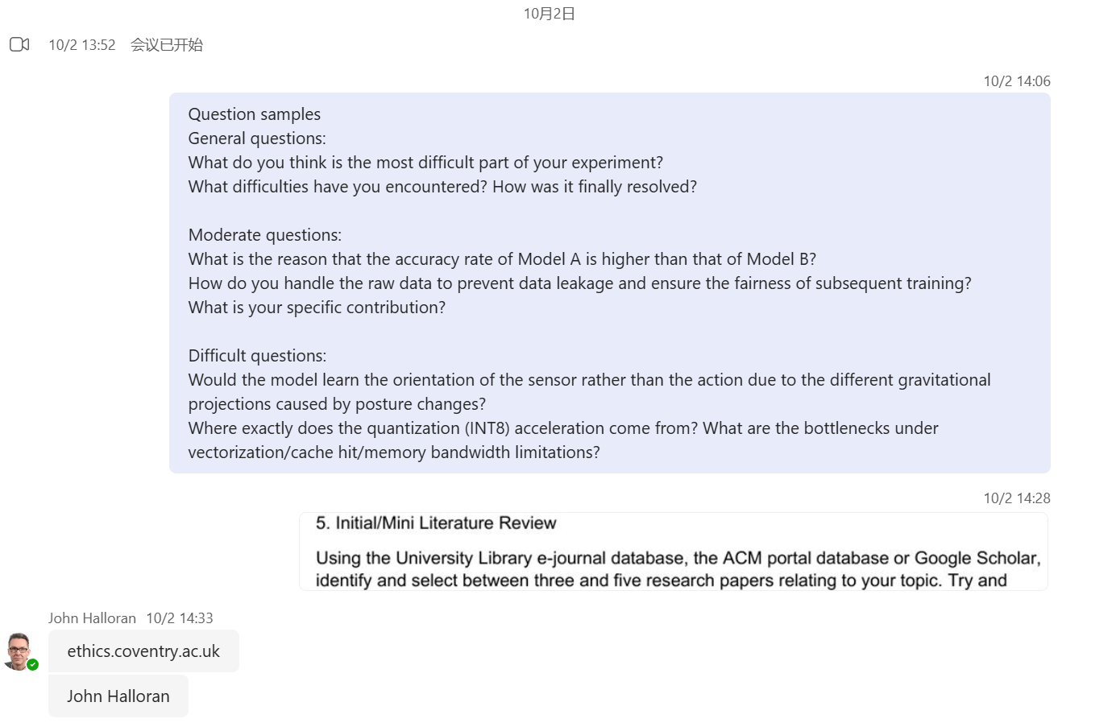
Answer
1. There won’t be very detailed questions, so you don’t need to worry too much.
2. In the conference papers I wrote before, I usually used more than 20 references, so having only five is far too few.

Email
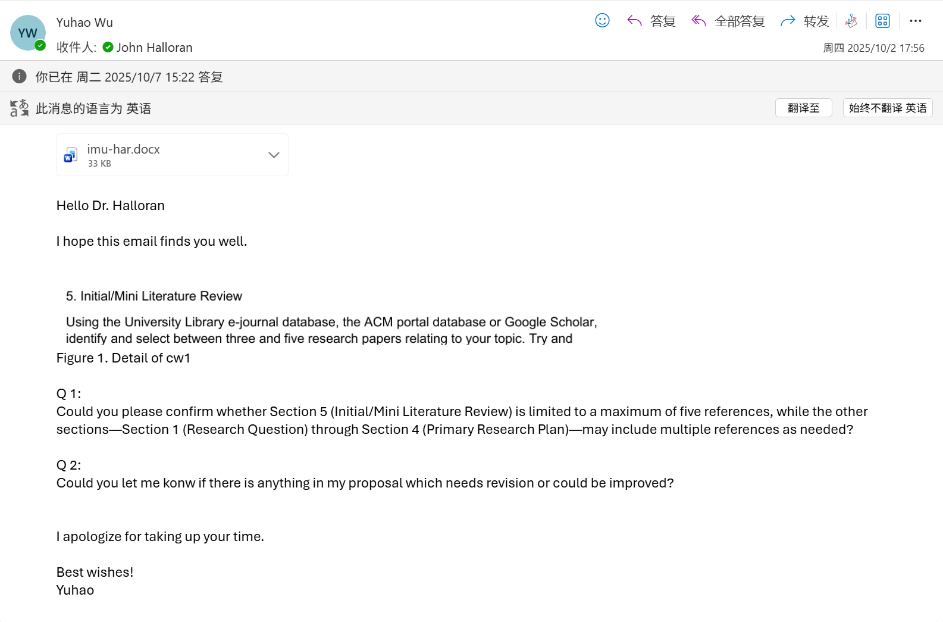
My supervisor did not reply this week because he was busy. The weekly document for next week records the feedback he gave me.

Computing Project
WORK DONE
1. Completed the ethics application.
2. Completed the first draft of the proposal.
3. Completed about 70% of the preprocessing for the RealWorld dataset.

Issues and challenges
- I am not very sure how to write a good proposal.
- The two datasets I originally chose are not allowed by the university, so I need to think about which datasets to switch to.
- How to make the preprocessing of the RealWorld dataset more standardised, rigorous, and closer to top conference/journal standards.

Actions for next week
1. Complete the remaining part of the preprocessing for the RealWorld dataset.
2. Wait for my supervisor’s feedback on the proposal draft and revise it.

Evidence
This was the first meeting and the only one I did not record. However, following my supervisor’s advice, I recorded all subsequent meetings.
